**ASSIGNMENT REPORT**

**How To Run The Program**

* Start the server program by typing the following command
  + Java FileTransferServer input.txt
  + Input.txt – Input file for the transfer
* Start the client program by typing the following command
  + Java FileTransferClient

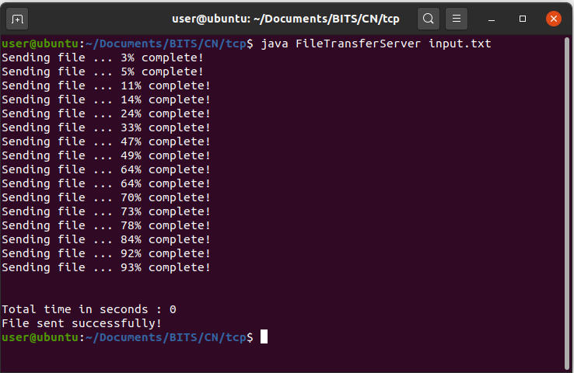

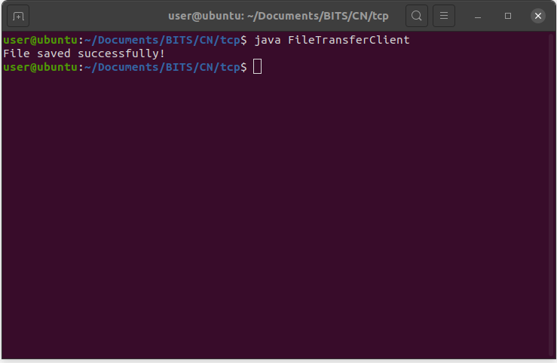**Time Taken**

|  |  |
| --- | --- |
| File Size | Time Taken (in seconds) |
| 200Mb | 1 |
| 500Mb | 4 |
| 800Mb | 6 |
| 1000Mb | 8 |
| 1500Mb | 11 |

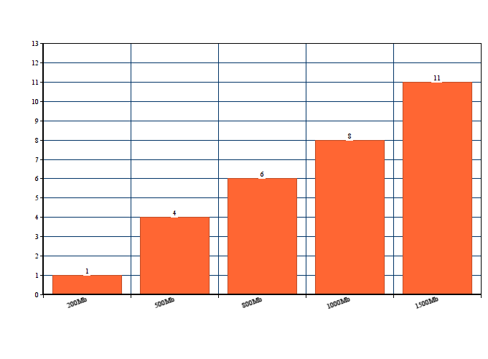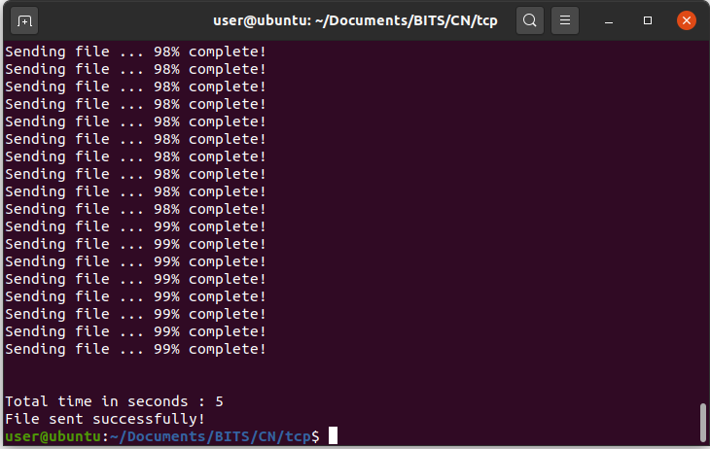

**Conclusion**

* File Size can’t exceed datagram size. If one needs to send bigger file, he has to split file before sending.